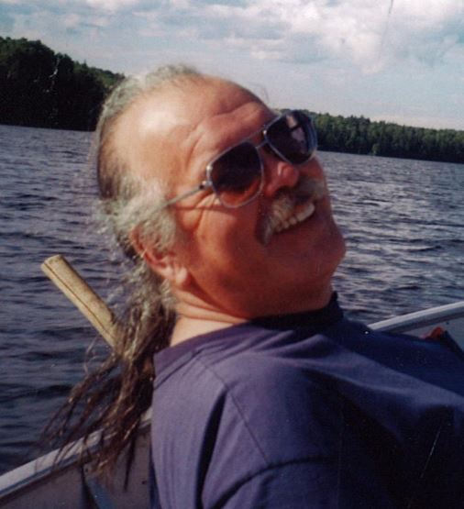

Passed away surrounded by his family at the Sault Area Hospital on Tuesday, April 11, 2017 at the age of 72. Survived by his loving wife and companion, Judy Murphy-Nolan, his son James and daughters Crystal and Peggy. Cherished grandfather of Amanda, Mitchell, Lance, Taynia and Kassandra. Predeceased by his infant son Richard, infant daughter, infant granddaughter Madison and his parents Alphonse and Florence “Maxi” Nolan. Dear brother of Richard, Michael and Diane. He will be fondly remembered by countless dear friends, cousins, aunties, uncles, nieces and nephews. Archie’s life was dedicated to healing, teaching and helping others. He was the first spokesperson for Missanabie Cree First Nation and was instrumental in the creation of this band – He called the family together and spent his life working to regain their rightful lands. In keeping with Archie’s wishes, there will be no funeral services. Memorial donations to the SAH Foundation would be appreciated by the family

